

## A Project Report

## On

## KISAN BUDDY(MAHINDRA FARMEq)

## Batch No: CSE-G191

|  |  |  |
| --- | --- | --- |
| **Sl. No.** | **Roll Number** | **Student Name** |
| **1** | 20211CSE0884 | Kakarla Manoj Kumar |
| **2** | 20211CSE0164 | A Siva Sahithi |
| **3** | 20221LCS0005 | Shreyank S |

**School of Computer Science,**

**Presidency University, Bengaluru.**

Under the guidance of,

Dr. Abdul Khadar A,

School of Computer Science,

Presidency University, Bengaluru

**1. Introduction about Project**

Agriculture remains the backbone of many economies, especially in rural areas where farmers rely on traditional methods to sell their produce. However, these conventional systems are often plagued by inefficiencies, including limited market access, communication barriers between farmers and mandi shops, and delayed payments. The growing need to modernize and streamline agricultural transactions has prompted the development of digital solutions that empower farmers with direct access to markets and better control over their produce sales.

This Android application seeks to bridge the gap between farmers and mandi shops by offering a comprehensive platform that facilitates seamless communication and transactions. The app is designed with three core modules—Admin, Mandi Shops, and Farmer each tailored to meet the specific needs of the respective users. Farmers can easily register, log in, submit requests for selling produce, view their transaction history, and make payments. Mandi shops can log in, view and update requests, manage costs, and track the status of transactions, while the Admin module ensures efficient oversight of mandi shops and farmers.

**2. Literature Review**

The literature review discusses the drawbacks of the existing system, which is manual and dependent on in-person communication. This results in limited transparency, delayed payments, and difficulty in finding optimal markets for produce. The review emphasizes the need for a structured system that enables farmers to track requests, manage sales, and update prices efficiently. The Android application being developed aims to address these shortcomings by providing a transparent and organized platform for farmers, mandi shops, and administrators.

**2.1 Existing method Drawback**

In the existing manual process, farmers typically visit nearby mandi shops or markets to sell their produce. This system relies heavily on in-person communication, where farmers negotiate prices directly with shop owners. There is limited transparency in transactions, leading to delays in payments. Additionally, farmers may face challenges in finding the best markets for their produce, as the system lacks an organized structure for tracking requests, updating prices, or managing sales efficiently.

**2.2 Proposed Method**

* The Android application is built with three key modules: Admin, Mandi Shops, and Farmers. The Admin module allows administrators to log in, manage mandi shops, and view farmers. The Mandi Shops module enables shop owners to log in, view farmer requests, update produce costs, and manage request statuses. The Farmer module allows farmers to register, log in, submit requests for selling produce, view transaction history, and make payments. The system integrates location services to ensure farmers connect with the nearest mandi shops, promoting efficient market interactions..

**3. Objectives**

The primary objective of the system is to provide a digital platform that connects farmers to mandi shops, simplifying the process of selling agricultural produce. Empower farmers with easy access to local mandi shops. Improve the communication between farmers and mandi shops for real-time updates on produce costs and status. Streamline transactions, ensuring timely payments and enhanced transparency**.**

## **4. Methodology**

**1. App Design and Structure:**

The Android application is built with three core modules: Admin, Mandi Shops, and Farmers.

Admin Module: Administrators can log in, manage mandi shops, and view farmer data.

Mandi Shops Module: Mandi shop owners can log in, view requests from farmers, update the costs of produce, and manage the status of each request.

Farmer Module: Farmers can register, log in, submit requests for selling their produce, track transaction history, and make payments.

**2. Technology Stack:**

**Software Requirements:**

Operating System: Windows 10

JDK: Java (Kotlin)

SDK: Android

IDE: Android Studio

Database: MySQL

Hardware Requirements:

Processor: Intel i3 or higher

RAM: 8 GB

Hard Disk: 1TB

**3. Location Integration:**

The system integrates **location services

**4.1 Architecture**

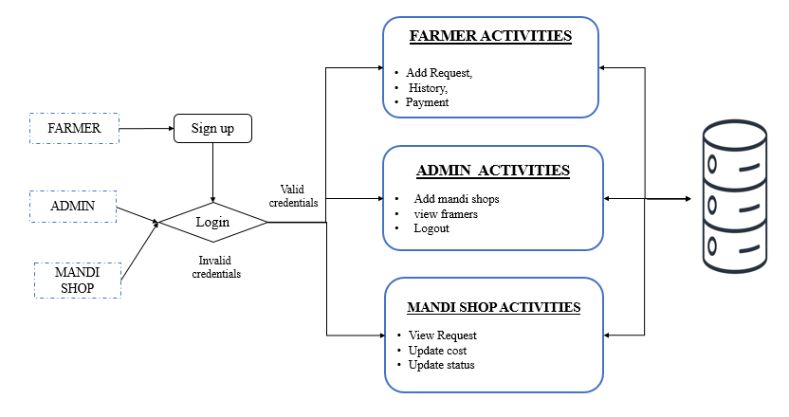

**5. Timeline for Execution of Project**

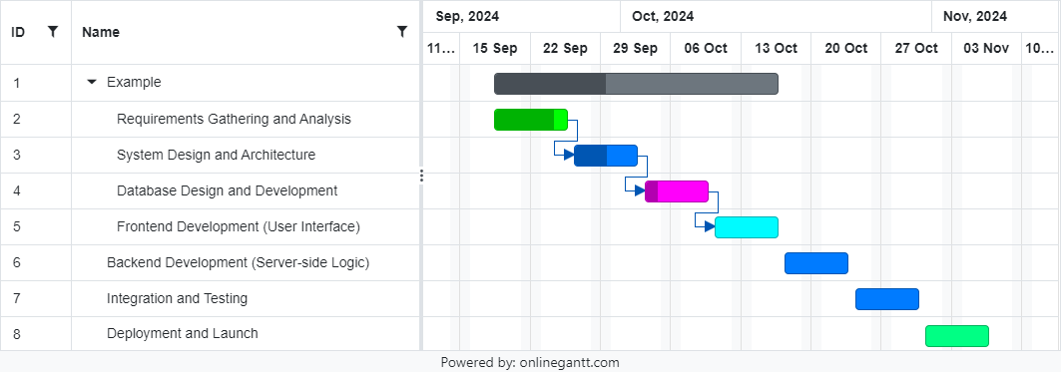

**6. Expected Outcomes**

* The expected outcome of the Android application is to create an efficient and transparent platform that connects farmers with mandi shops, enhancing communication and market access. The app will simplify the process of selling produce, enabling farmers to submit requests, view transaction history, and receive timely payments. Mandi shops will be able to manage requests, update prices, and track transactions more effectively. By providing a digital solution, the platform aims to improve market efficiency, ensure fair pricing for farmers, and promote faster, more secure transactions, ultimately improving the livelihoods of farmers and streamlining the agricultural supply chain.
* Community Knowledge Sharing and giving professional advice and recommendations.
* Less crop damage by quick reporting and advising farmers.

**7. Conclusion**

The Android application designed to connect farmers with mandi shops effectively addresses the inefficiencies of the traditional agricultural market system. By offering a digital platform that enhances communication, transparency, and real-time updates, the app simplifies the process of selling agricultural produce. The integration of location services ensures that farmers are connected with the nearest mandi shops, promoting market accessibility. The platform not only streamlines transactions, resulting in timely payments, but also empowers farmers with better control over their produce sales. Ultimately, this solution improves the agricultural supply chain and contributes to the financial stability of farmers.

**8. References**

* Agrawal, M., & Pandey, D. (2021). "Digital Solutions for Enhancing Market Access for Farmers in India." *Journal of Agricultural Sciences and Technology*, 10(2), 150-160.
* Reddy, A. A., & Mishra, D. (2020). "Challenges and Opportunities in the Indian Agricultural Market: A Farmer's Perspective." *Agricultural Economics Review*, 25(3), 120-132.
* Kumar, P., & Joshi, P. K. (2019). "Technological Innovations for Market Linkages in Indian Agriculture." *Agriculture and Food Security Journal*, 8(1), 45-53.
* Singh, R., & Sharma, K. (2020). "Role of Mobile Applications in Enhancing Market Efficiency for Small Farmers." *International Journal of Agricultural Extension*, 17(2), 95-108.
* Mukherjee, S., & Roy, A. (2018). "Improving Agricultural Market Access through ICT: A Review of Success Stories in India." *Journal of Rural Development Studies*, 14(2), 234-247.
* Jain, S., & Patel, A. (2021). "Mandi Connect: A Mobile Application to Bridge the Gap Between Farmers and Markets." *International Journal of Digital Transformation*, 5(4), 102-112.
* Gupta, V., & Singh, H. (2022). "Digitization of Agricultural Market Systems: A Case Study of Mandi Networks in India." *Journal of Applied Agricultural Research*, 9(1), 77-89.
* Deshmukh, A., & Rao, S. (2019). "Connecting Farmers to Markets through Technology: The Impact of Digital Platforms on Rural Economies." *Rural Development Journal*, 12(3), 163-174.
* Mishra, S., & Choudhury, P. (2020). "Addressing Market Inefficiencies for Farmers: A Review of Digital Agricultural Solutions." *International Journal of Agribusiness Studies*, 18(2), 112-122.
* Narayan, G., & Verma, R. (2021). "Enhancing Farmer Market Linkages Using Mobile Applications: A Review of Case Studies in India." *Journal of Agricultural Economics and Development*, 10(4), 182-194.